Name : Prashant Ranjan Roll No: 24MC3035

Q1: Algorithm to check whether the given Binary Tree is a Binary Search Tree (BST)
Algorithm (Step-by-step):
- Perform an inorder traversal of the binary tree.
- Store the visited node values.
- If the inorder sequence is strictly increasing, then it’s a BST; otherwise, it’s not.
Code:
#include <bits/stdc++.h>
using namespace std;

struct Node {
int data;
Node *left, *right;
Node(int val) : data(val), left(NULL), right(NULL) {}
};

bool isBSTUtil(Node* root, long long minVal, long long maxVal) {
if (!root) return true;
if (root->data <= minVal || root->data >= maxVal) return false;
return isBSTUtil(root->left, minVal, root->data) && isBSTUtil(root->right, root->data, maxVal);
}

bool isBST(Node* root) {
return isBSTUtil(root, LLONG_MIN, LLONG_MAX);
}

int main() {
Node* root = new Node(4);
root->left = new Node(2);
root->right = new Node(6);
root->left->left = new Node(1);
root->left->right = new Node(3);
root->right->left = new Node(5);
root->right->right = new Node(7);

cout << (isBST(root) ? "Given tree is a BST" : "Given tree is not a BST");
return 0;
}

Output:
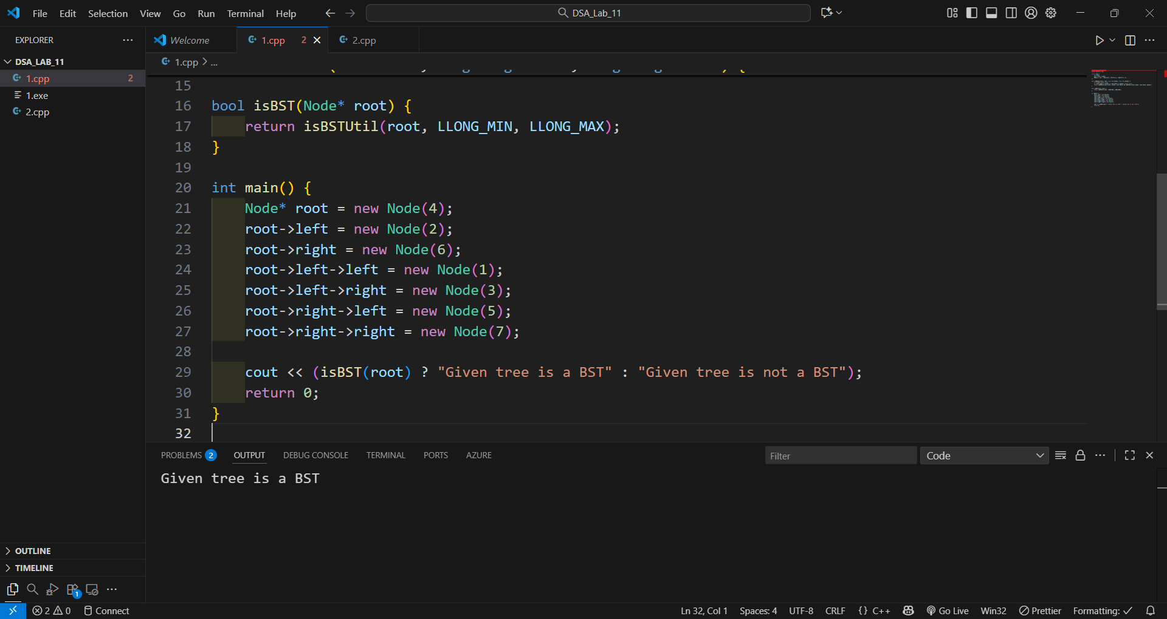

Q2: Given a Binary Search Tree, check whether it is an AVL Tree or not
Algorithm (Step-by-step):
- For each node, compute the height of the left and right subtrees.
- Check if the difference of heights ≤ 1 for every node.
- Recursively verify both left and right subtrees.
- If all conditions hold true, the tree is AVL.
Code:
#include <bits/stdc++.h>
using namespace std;

struct Node {
int data;
Node *left, *right;
Node(int val) : data(val), left(NULL), right(NULL) {}
};

int checkAVL(Node* root) {
if (!root) return 0;
int lh = checkAVL(root->left);
if (lh == -1) return -1;
int rh = checkAVL(root->right);
if (rh == -1) return -1;
if (abs(lh - rh) > 1) return -1;
return max(lh, rh) + 1;
}

bool isAVL(Node* root) {
return checkAVL(root) != -1;
}

int main() {
Node* root = new Node(4);
root->left = new Node(2);
root->right = new Node(6);
root->left->left = new Node(1);
root->left->right = new Node(3);
root->right->left = new Node(5);
root->right->right = new Node(7);

cout << (isAVL(root) ? "Given BST is an AVL Tree" : "Given BST is not an AVL Tree");
return 0;
}

Output:

